V.Epshteyn, P.Shatalov tests_2003 Note2, 2003-08-29

Some results of 2003 tests

1. Introduction

In this note we present results of data analysis of selected runs which we imported to ITEP (Table 1).
Table 1: Data sample used for the present analysis
beam type / position | P, GeV/c | runs # | number of events
electrons / 4H | 40 | 2845, 2846, 2847 | 36000
electrons / 4H | 60 | 3328, 3329 | 24000
electrons / 4H | 100 | 2687, 2688 | 24000
electrons / 4H | 200 | 2967, 2968 | 24000
electrons / 4L | 60 | 3242, 3243 | 24000
electrons / 4L | 100 | 2595, 2596 | 24000
electrons / 4L | 200 | 3223, 3224 | 24000
pions / 4H | 60 | 3294 | 12000
pions / 4H | 100 | 2649 | 12000
pions / 4H | 200 | 3043 | 12000
pions / 4L | 60 | 3259 | 12000
pions / 4L | 100 | 2613 | 12000
pions / 4L | 200 | 3193 | 12000

Runs 3242, 3243, 3328, 3329 (60GeV/c) were supposed to contain basically events with electrons. However, we found little but pions in these runs, therefore the 60GeV/c point for electrons is not presented in this note.

2. Signal amplitude

Let A_{i} be the signal value corresponding to the sample i=0,1…6. Three methods to reconstruct the signal amplitude A (to filter the signal) are considered (Fig.1):
- raw : A=max(A_{i}).
- parabola: A is the maximum of a parabola fit to A_{2,3,4}
- spline – A is the maximum the cubic spline drawn through all the samples.

Since the clock signal and the shaper signal is not synchronized there is an additional contribution to the energy resolution – the quantization noise. Its dependence on the filtering method is illustrated
by reconstruction of the simulated shaper signal with a random phase: the relative rms spread of the reconstructed amplitude is 6.8%, 3.7% and 2.6% for the “raw”, “parabola” and the “spline” methods, respectively. Similarly, the relative Gaussian σ of the electron peak in the total reconstructed energy specrum for 4H/200 GeV/c runs (see Section … for details) is, respectively, 9.1% , 6.4% and 5.8%.

The spline method is used for all the numbers quoted further in this note.

3. Pedestals

We considered three methods to obtain pedestals for each cell:
- P1 – use A₀ as a pedestal in each individual event;
- P2 – use A₀ averaged over beam events in the current run;
- P3 – use pedestal events in the current run to obtain the average pedestal.

As seen from the Table 2, the P2 method gives a better energy resolution than the method P1. The P3 method gives the results almost identical to the method P2.

Table 2: Measured energy resolution obtained with different pedestal subtraction methods

Beam | P1 |  | P2
Beam | Mean , ADC counts | σ,% | Mean, Adc counts | σ,%
e, 40GeV/c, 4H | 448 | 17.2 | 447 | 12.9
e, 100GeV/c, 4H | 1152 | 14.8 | 1155 | 11.0
e, 200GeV/c, 4H | 2332 | 6.4 | 2329 | 5.8
π, 200GeV/c, 4H | 1922 | 14.4 | 1922 | 12.1

“P2 “pedestals are used in the further analysys.

4. Channel gain equalization

The present analysis was done without FEB channel equalization (the calibration data was not used).

5. The calorometer response

The calorimeter response R was computed by summing all the cells together (in FEBs 6 and − 7 for electrons, and in FEBs 0, 1, 5, 6 and 7 − for pions), or selecting only the cells within the radius r_core = (4, 8, 12, 16) cm from the cell with the highest amplitude. Respectively, we refer to these R-values as the “total” and “core” responses.
R_{e} = FCAL1 (FEB#6,7)
R_{π} = FCAL1 (FEB#6,7) + g2⋅FCAL2 (FEB#5)+g3⋅FCAL3 (FEB#0, 1)

Factors g2 and g3 were obtained by minimizing the resulting energy resolution (see Fig.3). Data favor g2=g3=2. This value is in a good agreement with g2=2.1 resulting from 1998 calibrations of FCAL1 and FCAL2 with electrons.

Technically, the cell summation is performed as follows:
- first, the sample amplitudes A_{i} in the selected cells are summed up, sample-by-sample, to obtain the sequence of 7 integrated sample amplitudes ;
- the filtering method (a spline fit in our case) is applied to this sequence. We currently abandoned the alternative approach, whereby the individual cell signals are first filtered and then the resulting amplitudes are summed, because of the ambiguities related to filtering of channels that were not fired and contain nothing but pedestals.

  - Events selection. Muon counter is the most effective tool to clean samples. Cuts on other counters and BPC's do not improve the situation (Fig.4a-4d, data - electrons, 4H, 200GeV/c). Note that mean (R) and sigma (R) from Gaussian fit do not depend on cuts.

Cuts# | cut description | Number of events | mean(R),  ADC count | sigma(R),  %
 | no cuts | 10561 | 2324 | 5.8
 | PH(muon counter)<20 | 7872 | 2324 | 5.8
 | Cut#1 & PH(veto counter)<10 | 5864 | 2327 | 5.8
 | Cut#1 & 0.5<counters_signal<1.5¹ | 5980 | 2329 | 5.9
 | Cut#1 & 0.5<chambers_signal<1.5² | 5791 | 2328 | 5.8
 | Cut#1 & |angleX|<0.5mrad | 7117 | 2326 | 5.8
 | Cut#1 & -1mrad<angleY<-0.5mrad | 7008 | 2329 | 5.8
¹ - ${\text{counters}}_{\text{signal}}=\frac{1}{3}\sum_{i=1}^{3}{\frac{\text{PH}{\left(\text{counter}\right)}_{i}}{\text{median}\left({\text{PH}}_{i}\right)}}$
² - ${\text{chambers}}_{\text{signal}}=\frac{1}{\text{12}}\sum_{i}^{\text{12}}{\frac{\text{PH}{\left({\text{anode}}_{\text{chamber}}\right)}_{i}}{\text{median}\left({\text{PH}}_{i}\right)}}$

Electrons
Distributions of R and results of the Gaussian fit are shown in Fig.5 and in theTable below.

P, GeV/c | position | Spline: mean, ADC count | σ, %
P, GeV/c | position | total | r_core, cm
P, GeV/c | position | total | 4 | 8 | 12 | 16
40 | 4H | 447 | 12.9 | 423 | 7.4 | 438 | 7.4 | 443 | 8.8 | 445 | 10.5
100 | 4H | 1155 | 11.0 | 1096 | 5.5 | 1.131 | 5.3 | 1143 | 5.9 | 1148 | 7.5
100 | 4L | 1161 | 10.9 | 1107 | 5.4 | 1139 | 5.3 | 1151 | 5.8 | 1153 | 7.0
200 | 4H | 2329 | 5.8 | 2237 | 6.4 | 2302 | 5.6 | 2324 | 5.5 | 2327 | 5.7
200 | 4L | 2196 | 6.4 | 2116 | 6.8 | 2168 | 6.3 | 2188 | 6.2 | 2193 | 6.2

Comments:
- 99% of R_total is contained in a region with r_core<8cm. Resolution for this region:
$$\frac{σ}{E}≈\frac{1\text{.}6\text{\%}}{E(\text{GeV})}⊕\frac{\text{35}\text{\%}}{\sqrt{E(\text{GeV})}}⊕5\text{.}2\text{\%}$$
- One can see from the Table that at 100GeV/c the R_total resolution is large. That results from a larger noise in runs at 100GeV/c (see total noise in FEB#7+FEB#6).

runs | Noise, ADC count
E, 40, 4H | 51.8
E, 100, 4H | 105.0
E, 200, 4H | 51.9

See below – noise problem paragraph.

• Τhe R distributions are well described by Gaussian for one and half order of magnitude (Fig.6). At lower level there is a long tail on the left side. Partly the tail can be explained by a pion contribution. Radial cuts reduce the tail (Fig.6-7).

  - Map of energy deposited in FCAL1 is shown in Fig.8. It shows an electromagnetic shower profile. Events with a beam particle that hits the same cell were selected.

Hadrons
Distributions of R and results of the Gaussian fit are shown in Fig.8 and in theTable.

P, GeV/c | position | Spline_data: mean, ADC count | σ, %
P, GeV/c | position | total | r_hit, cm
P, GeV/c | position | total | 4 | 8 | 12 | 16
60 | 4H | 567 | 28.3 | 337 | 37.5 | 459 | 24.3 | 512 | 20.7 | 540 | 20.8
60 | 4L | 589 | 26.4 | 362 | 30.3 | 468 | 20.0 | 522 | 17.5 | 548 | 17.4
100 | 4H | 991 | 32.4 | 540 | 35.7 | 755 | 19.6 | 843 | 17.5 | 889 | 19.3
100 | 4L | 1033 | 33.2 | 593 | 25.0 | 772 | 16.2 | 865 | 15.3 | 915 | 18.3
200 | 4H | 1921 | 11.4 | 1267 | 27.5 | 1654 | 16.6 | 1803 | 12.1 | 1872 | 10.9
200 | 4L | 1894 | 11.2 | 1305 | 22.8 | 1627 | 13.4 | 1755 | 10.6 | 1841 | 9.8

Comments:

The region of r_core<16cm contains ~95% of R_total. Stochastic term: $a\sqrt{E}≈\frac{\text{130}÷\text{140}}{\sqrt{E(\text{GeV})}}\text{\%}$, constant term – (3-5)%. Limited range of beam energies does not allow to make more precise estimates.
- Similar to electrons, there is a noise problem at 100GeV/c, in this case in FEB#7,6,5,1,0.

runs | noise, ADC count
π, 60, 4H | 86.0
π, 100, 4H | 200.7
π, 200, 4H | 86.0

- The energy resolution vs. 1/sqrt(E) is shown in Fig.9. The electronic noise is subtracted.

Noise problem
The Table shows noise in FEB's.

runs, 4H | FEB#0 | FEB#1 | FEB#5 | FEB#6 | FEB#7
e, 40GeV/c | 50.9 | 47.8 | 50.8 | 41.5 | 43.1
e, 100GeV/c | 57.0 | 66.5 | 63.4 | 65.4 | 60.7
e, 200GeV/c | 48.3 | 49.2 | 50.8 | 41.2 | 43.4

- These values correspond to P2 pedestals.
- Channel noise for different FEB's is shown in Fig.10. There is an additional contribution in the first thirty channels for all runs at 100GeV/c. One can see a correlation between FEB's (Fig.11). At 40, 60, 200GeV/c such a noise is not seen.
- The origin of this effect is unknown. May be it is due to improper setting of FEB's control.

Figures
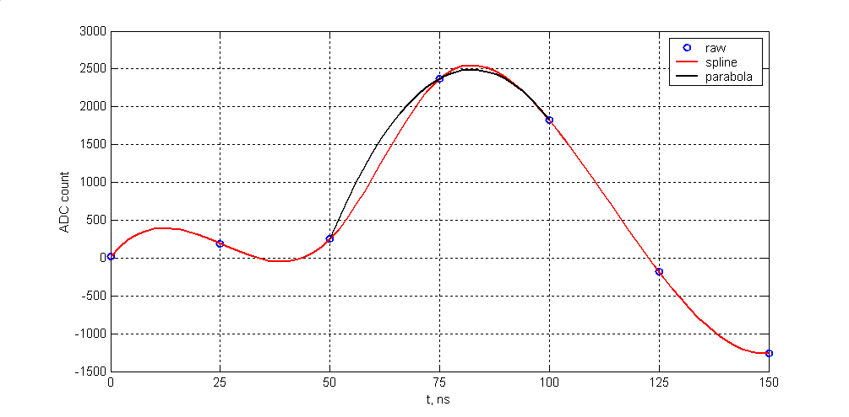Fig.1. Example of a signal shape, electrons, 200GeV/c

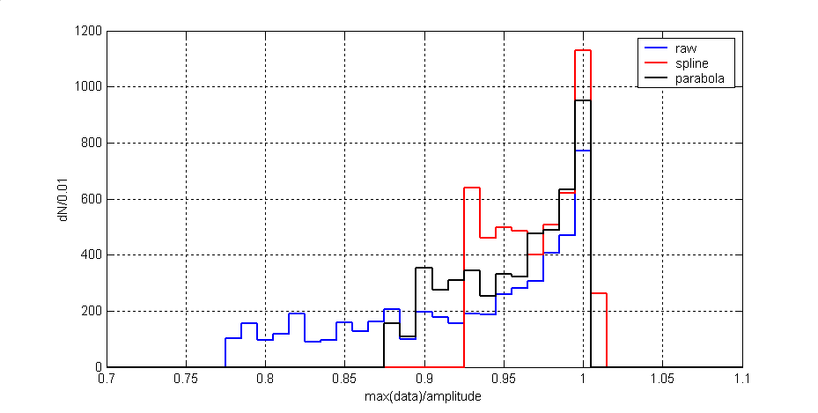Fig.2. Amplitude distributions, model data,
parameter – method of calculation
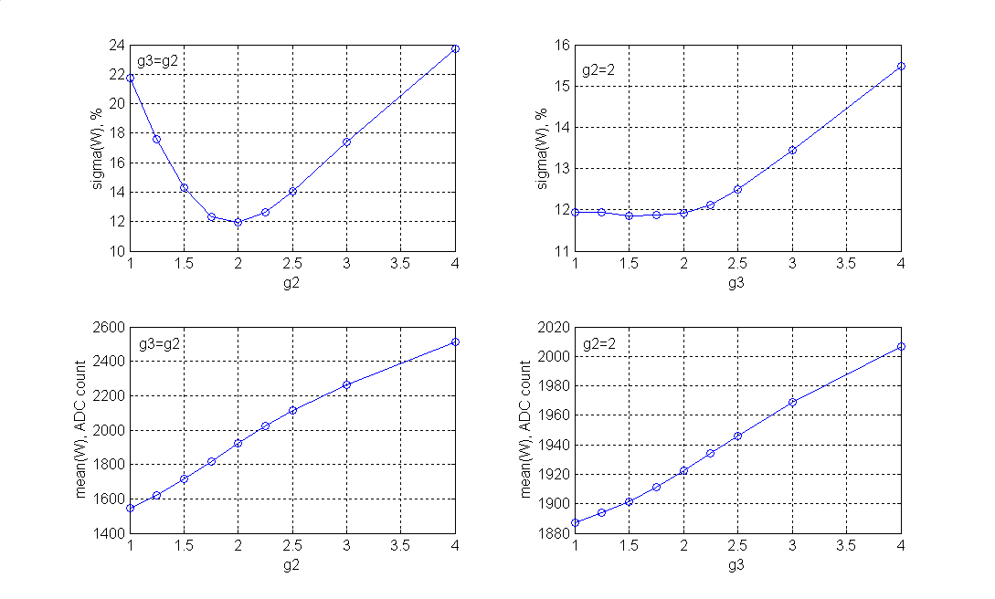Fig.3. The variation of the weight coefficients g2, g3, pions 200GeV/c
sigma(R), %
sigma(R), %
mean(R), ADC count
mean(R), ADC count
R=FCAL1+g2*FCAL2+g3*FCAL3
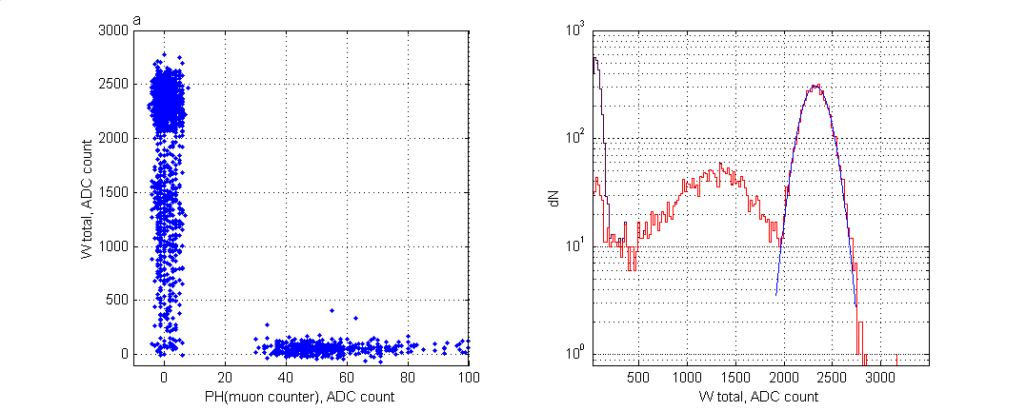
R_total, ADC count
R_total, ADC count

Fig.4a. Events cleaning, 4H, 200GeV/c,
___no cuts, ___PH(muon counter)<15, ___Gauss fit
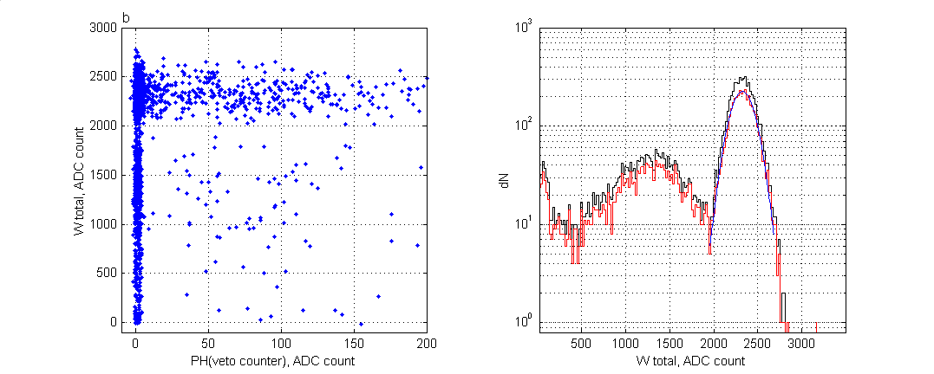
R_total, ADC count
R_total, ADC count
Fig.4b. Events cleaning, 4H, 200GeV/c,
___PH(muon counter)<15, ___& PH(veto counter)<15, ___Gauss fit
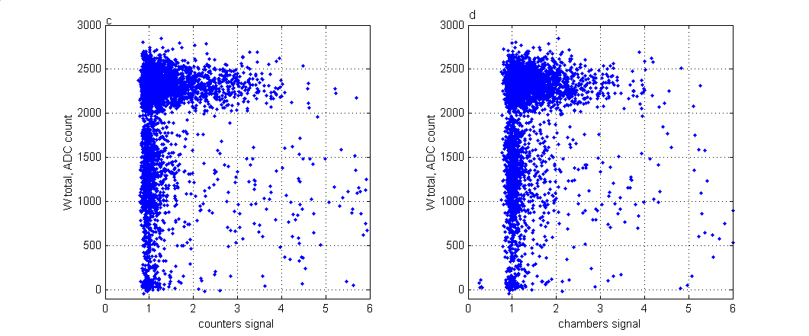
R_total, ADC count
R_total, ADC count
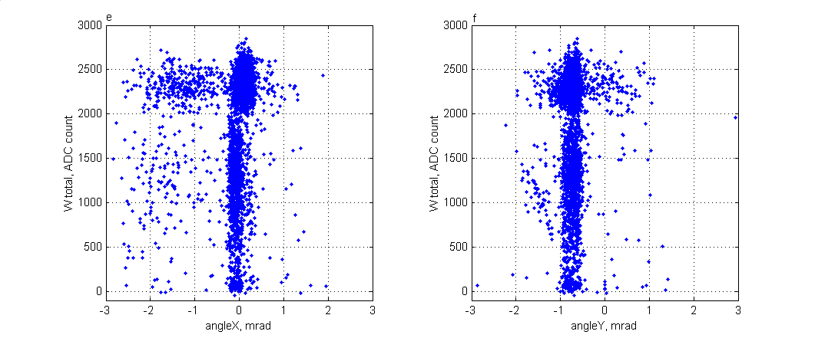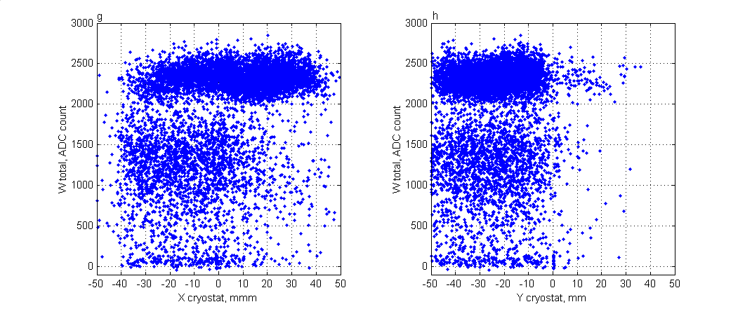Fig.4c-h. Plots R_total vs.:
R_total, ADC count
R_total, ADC count
R_total, ADC count
R_total, ADC count
c – counters_signal, d – chambers_signal,
e – angleX, f – angleY,
g – X of cryostat, h – Y of cryostat.
Electrons, 4H, 200GeV/c,

R_core, ADC count
R_core, ADC count
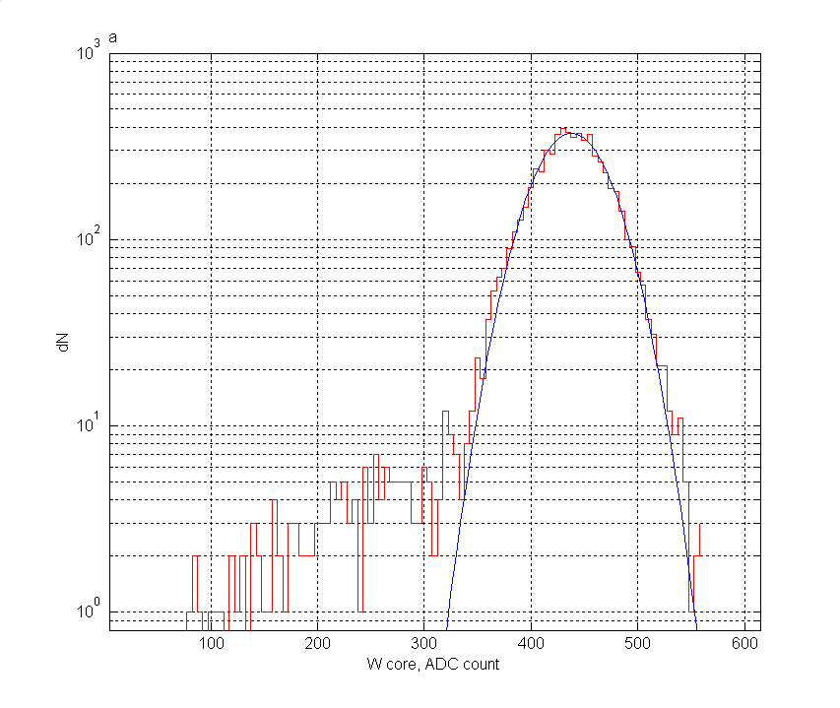
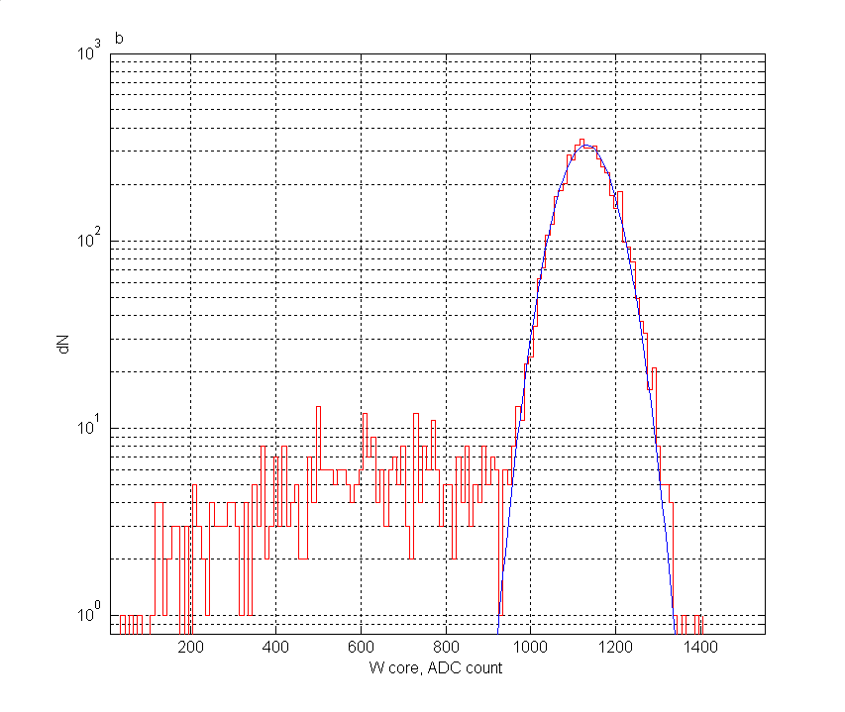
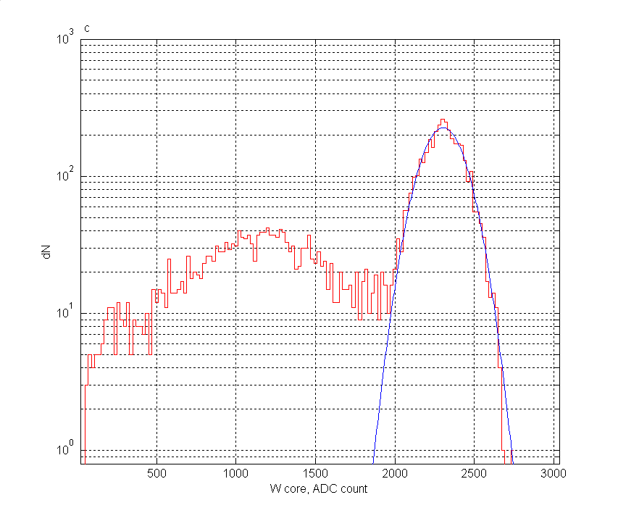
Fig.5. The distributions of R_core(8cm), electrons, 4H:
R_core, ADC count
a – 40GeV/c, b – 100GeV/c, c – 200GeV/c

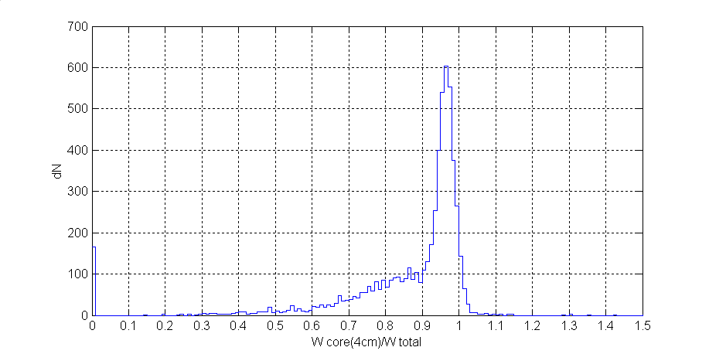
R_core(4cm)/R_total
Fig.6. The distribution of (R_core(4cm)/R_total), electrons, 4H, 200GeV/c

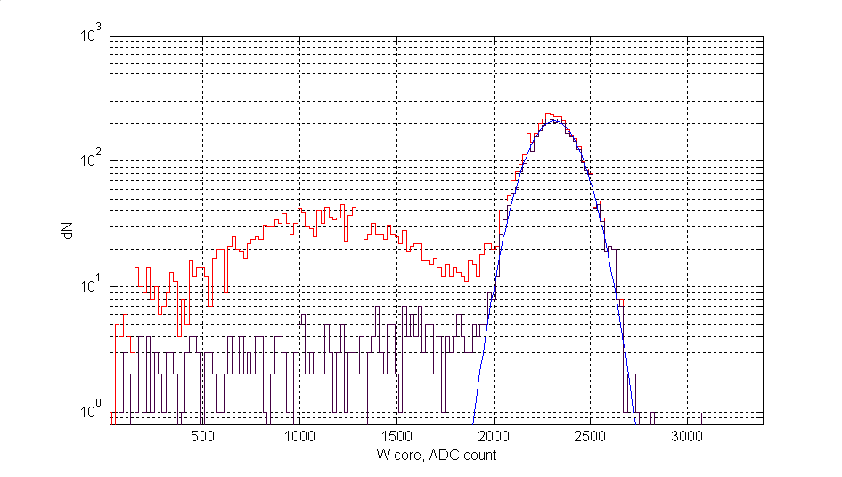
R_core, ADC count

Fig.7. The distributions of R_core(8cm):
___data, ___data(cut), ___Gauss,
cut: 0.9<R_core(4cm)/R_total<1.05

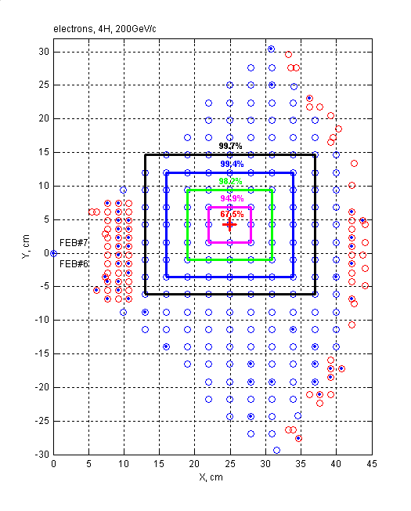
Fig.8. FCAL1 map, electrons, 4H, 200GeV/c:
+ - beam position
o – cell centers,
o – cells with 4 tubes,
. – cells with “negative” energy R,
___ - energy deposited inside a contour,

Min(R)=-0.15 ADC count. Total “negative” R=-1.8 ADC count (-0.08%R).

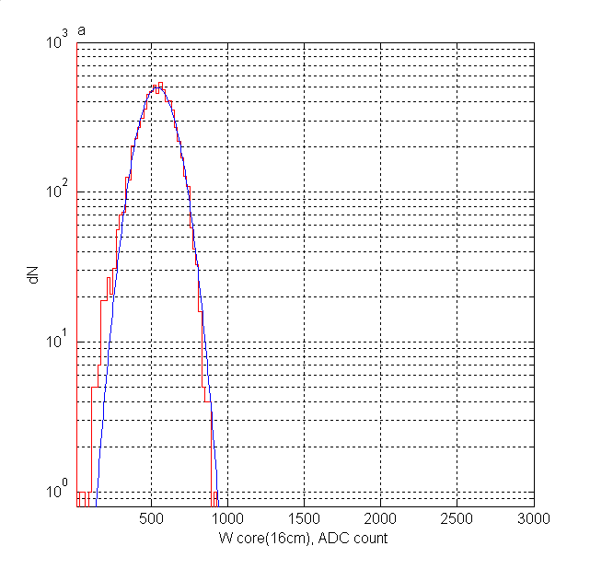
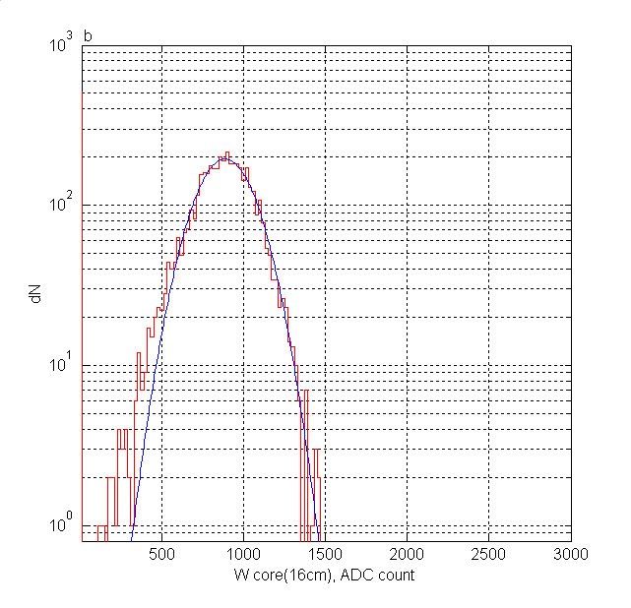
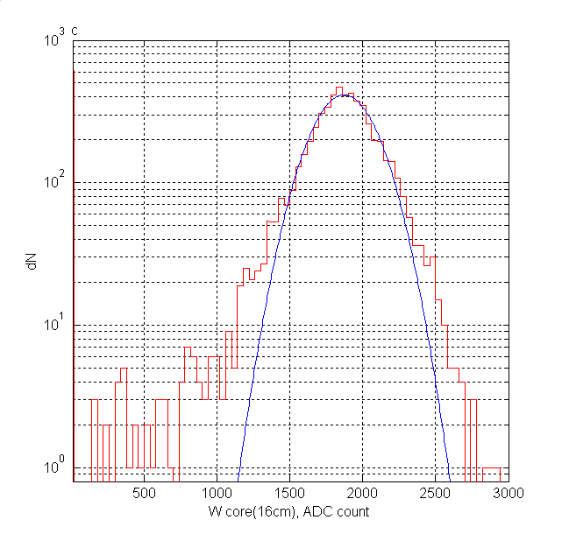
Fig.8. Distribution of R_core(16cm), ),
R_core(16cm), ADC count
R_core(16cm), ADC count
R_core(16cm), ADC count
pions, 4H, a – 60GeV/c, b – 100GeV/c, c – 200GeV/c
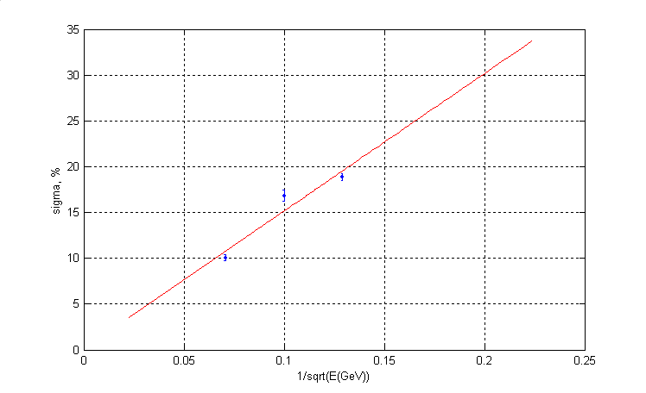
Fig.9. Sigma(R_core(16cm)) vs. 1/sqrt(E), hadrons, 4H,
the noise is excluded

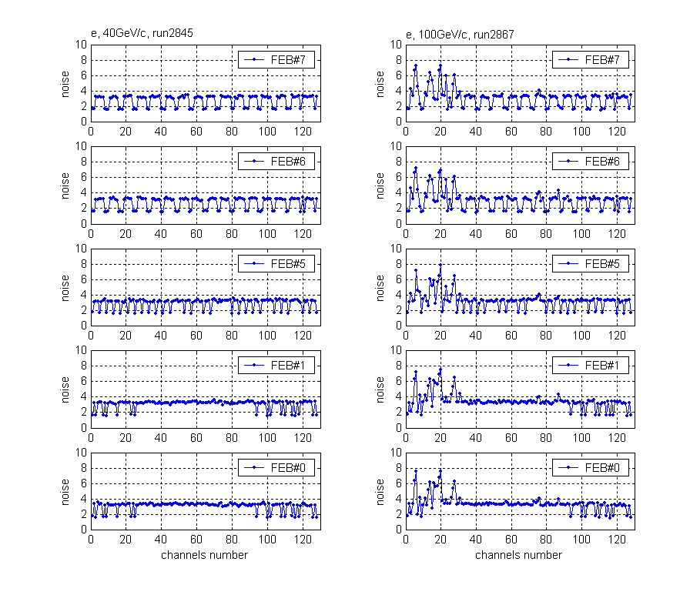
e, 100GeV/c, run2967
Fig.10. Noise in different channels of FEBs, [noise]=ADC count
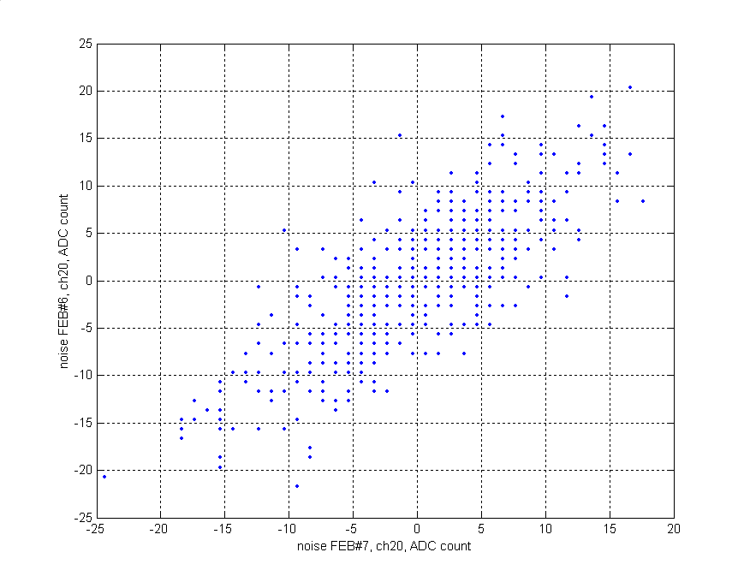
Рис.11. Plot noise(FEB#6, ch20) vs. noise(FEB#7, ch20), π, 4H, 100GeV/c

A triangular primary signal shape with Δt=50ns without fluctuation of an amplitude is used.
The quoted numbers correspond to the “total” column in Tables …(Section …) and … (Section …).

