A summary by PG 17 March 2004

ITEP Beam chambers

1. The beamline

The beamline is sketched in Fig. 1. There are three stations of beam profile chambers (BPCs): the far station located near bend magnet 6, about 30 m upstream the cryostat, the middle station (~19 m upstream) and the near station, mounted on the lifting table near the cryostat, together with the MPI MWPCs. The far and the near stations are equipped with high-precision X-Y BPCs (Fig. 2). They are used for the beam track reconstruction (to predict the impact point position). The middle station is equipped with single-projection, low-resolution “old” ITEP BPCs. Each station gives two independent measurements of a beam particle position. By requiring these two measurements to be compatible, one gets a powerful direct method of rejecting non-Gaussian measurements errors caused by δ-electrons. Genuine overlaying beam tracks can also be rejected on the event-by-event basis (see section 4).

The structure of both types of BPCs is schematically shown in Fig.3. The gas volume in the chambers is formed by the frame and 50 μm-thick Mylar windows. The chambers, together with amplifier-shapers, are contained in metallic housings having 20 μm-thick aluminized Mylar windows.

Appendix A gives a summary of materials currently situated in the H6 beamline, as well as the Z-positions of different elements.

2. The design of X-Y chambers

The ITEP BPC is a three-electrode multi-wire proportional chamber with cathode delay line readout. The anode plane has 25 wires of 20 μm in diameter, with 6 mm wire spacing. The cathode planes are placed at both sides of the anode plane, forming two sensitive gaps of 5 mm. The cathode planes have 31 wires of 100 μm in diameter, with 4 mm wire spacing, perpendicular to anode wires.

The total working area of the chamber is 120×120 mm².

The corresponding wires of the two cathode planes are connected together at one end and the combined signals are routed to the nodes of a lumped delay line. Each of the two ends of the delay line (further referred to as right and left channels) is connected to a separate amplifier-shaper.

All anode wires are joined together and connected to an anode amplifier.

Two such chambers (“planes”), rotated by 90⁰ to each other, are mounted in a common housing, and make a unit to measure two independent coordinates (X and Y) . The distance between the anode planes is 26 mm. The housing, with the external windows of aluminized mylar, also serves as an electromagnetic shield. A grounded wire plane similar to the cathode planes is placed between the chambers, to prevent cross-talks.

The working gas is Ar-CO₂ mixture (80% Ar :20% CO₂ in our case). The working HV is about 2250 V, with the detection efficiency of practically 100%.

For electronic calibration purposes, an external pulser signal is sequentially applied to the delay line nodes of wires 7, 16 and 25 in each chamber.
The average resolution of a single plane within a 60×60 mm area is σ≈130 μm.

3. The design of low-resolution chambers

These chambers have only one read-out plane. To obtain two X-Y points, 4 such chambers are installed in the middle station. Like the X-Y chambers, they have a delay-line read-out. The anode plane consists of 40 wires with the diameter of 20 μm and 3 mm spacing (plus a few thick guard wires at the plane extremities). The active cathode plane also has 40 wires and 3 mm spacing, but the wires diameter is 100 μm. The passive cathode consists of ~120 wires of 100 μm. The gas is 90% Ar :10% CO₂ .

The average resolution of a single plane within a 60×60 mm area is σ≈300-350 μm.

4. The readout

The analog signals from front-end amplifier-shapers are carried by coaxial cables to external NIM discriminators. The timing of these signals is digitized by TDCs. The reconstructed coordinated are derived from the readings of the R- and L- BPC channels.
The approximate relationship (good for on-line monitoring) is:
X ≈ G_{X} ( t_{L} – G_{RL}t_{R} - t₀ )

where . G_{X} ≈0.05 mm, G_{RL}≈1 and t₀ ≈0. For the reconstruction, a more sophisticated formula is used, with the constants determined from the on-line calibration. For the purpose of MC simulation, one can use the following simple model to generate the TDC counts t_{L} and t_{R} from the particle coordinate X:

$\begin{aligned}t_{L}=\frac{1}{2}\left(\text{1200}+\frac{X(\text{mm})}{0\text{.}\text{05}}\right) ; \left|X\right|≤\text{60}\text{mm} \\ t_{R}=\text{1200}−t_{L}\end{aligned}$

The coordinate X can be smeared with the appropriate σ (130 or 300 μm). These formulae do not take into account the drift-time of electrons in the MWPC gap, which adds a common offset to t_{L} and t_{R} . This offset cancels in the difference t_{L} - t_{R} which is important for the co-ordinate measurement.

A distinct feature of the delay-line readout is that for single tracks the sum t_{L} + t_{R} has a sharp lower limit (in the above simple model the sum is just constant). In the case of genuine track overlays the sum can be (although not necessarily!) less than this limit. This permits to reject overlays even with a single BPC. With several BPCs the multitrack rejection is unambiguous.

References

1. ITEP group: ITEP Beam chambers, ITEP BPC-2003-Note 1
http://cern.ch/atlas-fcaltb/Memos/Hardware/BPB/BPC_Note1-2003.pdf
2. V. Epstein: A design and performance of the high-precision MWPC with delay-line readout(in Russian)
http://cern.ch/atlas-fcaltb/Memos/Hardware/BPC/ITEP_BPC_design_Rus.doc
3. P.Gorbunov: ITEP Beam Chambers, a presentation at the CBT EC2 Planning Meeting, 12-Nov-2003, CERN
http://atlas-fcaltb.web.cern.ch/atlas-fcaltb/Memos/Hardware/BPC/BPC CBT EC2.pdf
Figure 1: The layout of the BPCs in the H6 beamline.
Figure 2: ITEP X-Y beam chamber.
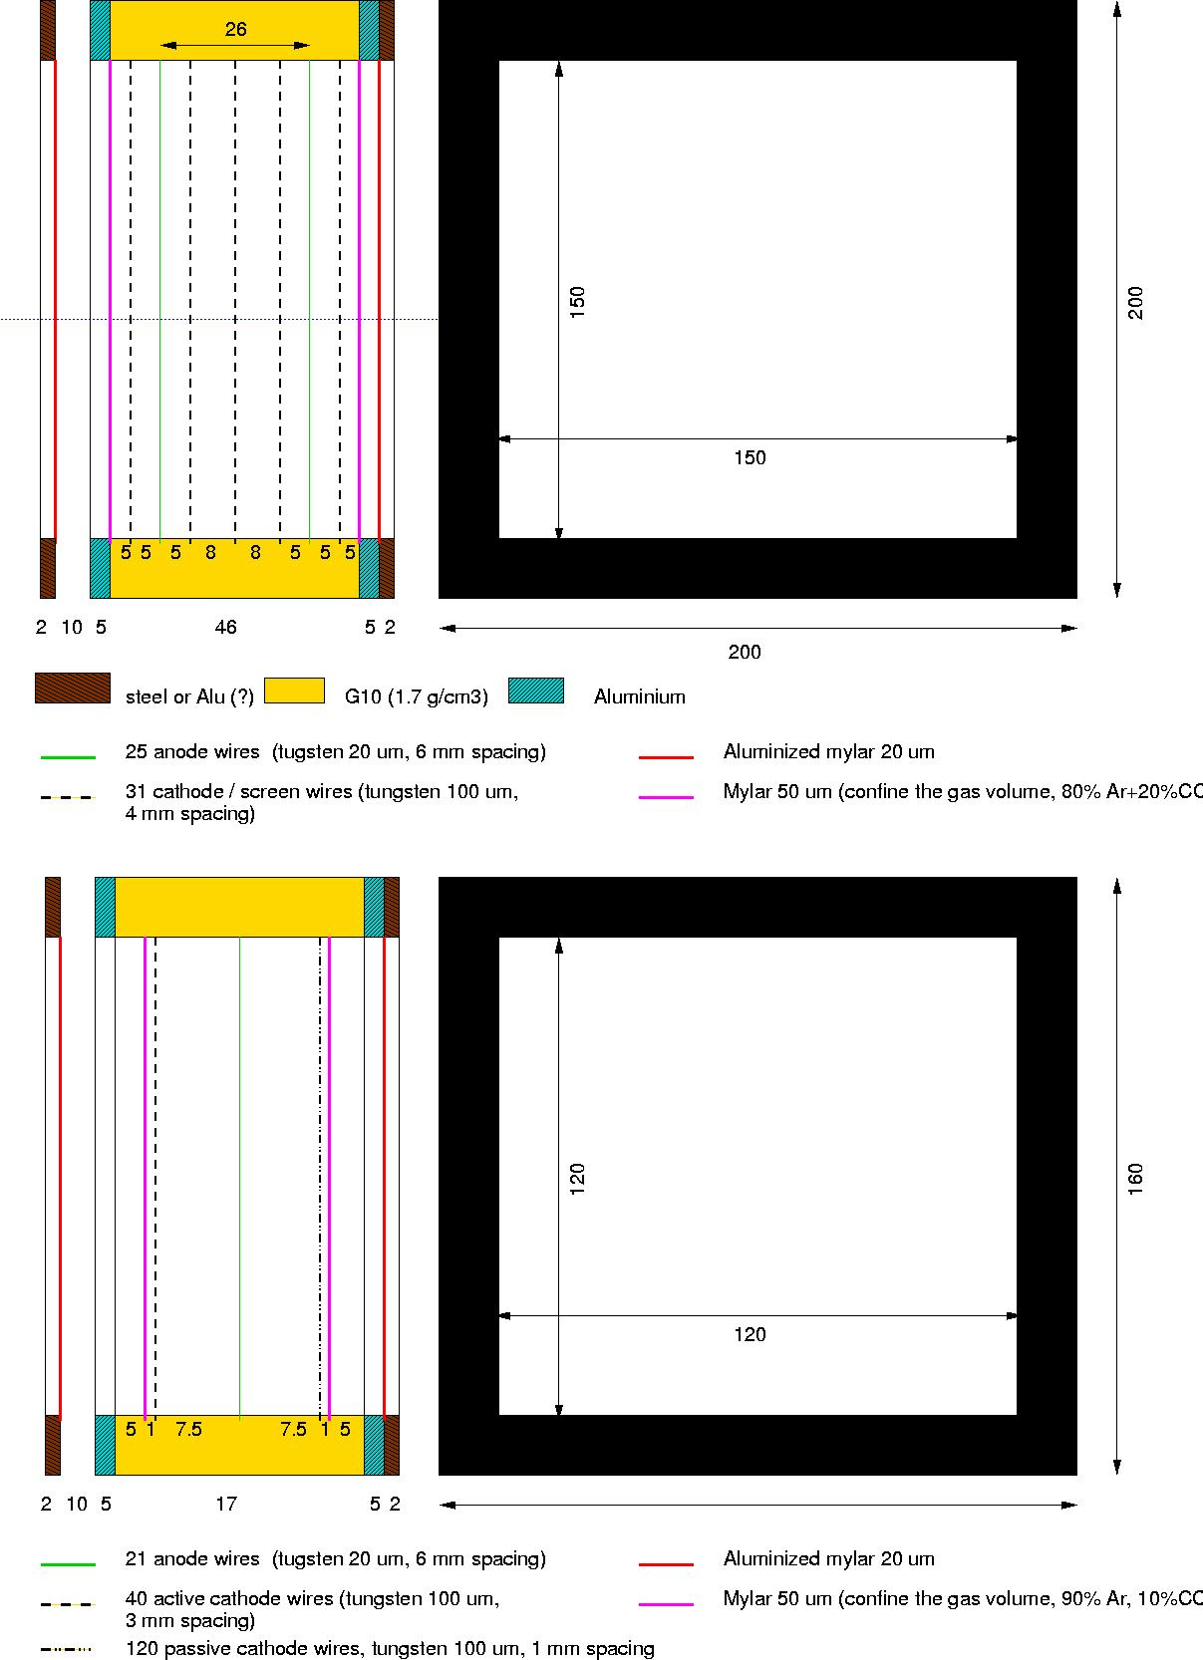
Figure 3: A sketch of ITEP BPCs structure (not to scale!). Top: high-precision X-Y chambers used in the far and the near stations; bottom: low-precision X-only chambers used in the middle station. The gas volume is contained between 50 μm Mylar windows shown in purple.
Appendix A: Materials in the H6 beam line during the FCal 2003 tests

---Z (cm)--------------------------- Description
-3156.1 Vacuum pipe window out 120 micron mylar
-3085.3 BPC1 1*(W:0.022 + mylar:0.020) g/cm2
40 mm of (80%Ar+20%CO2) =1.41 air density
-3069.5 BPC2 same
-3024.3 Vacuum pipe window in 120 micron mylar
------------------------------------
-2439.0 Vacuum pipe window out 120 micron mylar
------------------------------------
-1982.9 BPC3x 2*(W:0.022 + mylar:0.014) g/cm2
2*30 mm of (90%Ar+10%CO2) =1.39 air density

-1975.6 BPC3y same
-1968.3 BPC4x same
-1961.0 BPC4y same
-1919.5 Vacuum pipe window in 120 micron mylar
------------------------------------
-914.6 Vacuum pipe window out 120 micron mylar
------------------------------------
-400.0 S1 10*10*1 cm3 scintillator
-393.9 Veto 60*60*1 cm3 scintillator, with
central hole 6.5 cm diam
-314.6 BPC5 same as BPC1
-304.8 BPC6 same
-229.2 S2 same as S1
-226.8 S3 7*7*1 cm3 scintillator
------------------------------------
-439.0 MPI MWPC1 ?? take the same as BPC1
-361.0 MPI MWPC2 same
-263.0 MPI MWPC3 same

See [Ref.1] for more details.

