3.1 Principle:
The calibration pulses are generated by pulsers the
principle of which is described on Figure 1.
The fast output voltage pulse is obtained by
interrupting a precise DC current Ip that flows in the
inductor. When a pulse command is applied on Q2, Q1 is
cut off and the current is diverted to ground. The
magnetic energy stored in the inductor produces a voltage
pulse with an exponential decay across the parallel
combination of the cable characteristic impedance Zc and
a termination resistor Ro of the same value. This pulse is
propagated inside the cryostat through a 7 m long 50 .
cable adapted at both ends and is applied across a precise
injection resistor Rinj (0.1%) in the cold, directly to the
electrodes. The resulting current is given by:
An amplitude up to 10 mA can be achieved by
applying a 5V pulse in a 500 . injection resistor.
The main difficulty of this calibration system is to
distribute uniformly throughout the calorimeter a very
precise voltage pulse. To minimise the attenuation due to
skin effect, the pulsers are located close to the
feedthrough.

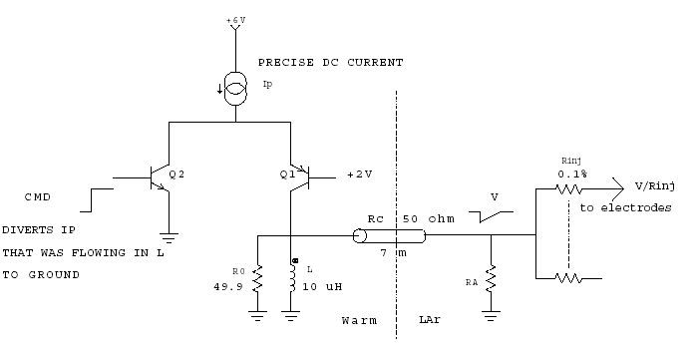
Figure 1 : Principle of the pulser

3.2 Complete design

The current Ip is generated from a 18 bits DAC voltage
through a voltage to current converter. The current in the
output branch is I1=VDAC/R20, as negligible current
flows in the gate of the JFET transistor. A low offset op
amp as OP 07 must be used, as Voffset = 100 ∝V already
corresponds to 15 LSB.
To insure good linearity, the base current of Q1 which
varies non linearly with Ip (®varies with the collector
current and the temperature) is measured and added to Ip.
Q1 is made of 4 transistors in parallel to share the large
DC current for Ip (up to 200 mA) and to keep a low Rcc,
necessary for the wide dynamic range.
Five precision resistors (0.1%) determine the calibration pulse accuracy.

Figure 2 : Schematics of the analog part

