P. Gorbounov, Draft 1, 17-21 February 2005
On the table1 scale calibration

The platform for the middle BPC station (the “table-2") has a lifting mechanism with the remote control permitting to set the movement direction and speed. The motor has no position encoding. Instead, the platform height is constantly monitored with an analog system based on a precision linear transducer. It consists of a high-stability linear potentiometer, with the slider fixed on the table support and the resistive tape moving together with the platform. The potentiometer is connected to a stabilized current source (contained in the control box), so the voltage on the slider is proportional to the platform position. This voltage is measured with a digital voltmeter having a resolution of 1 mV (this roughly corresponds to 0.04 mm). The full platform (and the transducer) stroke is about 40 cm, but we used only ~20 cm in 2004.

In my calibration measurements, instead of trying to reproduce the 2004 voltage settings, I was lifting the platform to fixed heights, using a floppy steel 0.5 mm-grade ruler and a gauge attached to the platform, see Fig. 1. The voltage readings were recorded for each height setting. The height was measured with respect to the table support. The accuracy of adjusting the platform gauge to the ruler marks (I was using more visible 1 cm marks) was better than 0.1 mm, by eye. However, the real accuracy, as will be shown later, was ±0.2 mm - probably, because of non-flatness of the table support and insufficient rigidity of the ruler.

During two days (February 14-15, 2005) I made 4 series of measurements, each time going over the whole range of table heights used in 2004, in both directions. The first 3 series were separated by several full-range up and down movements. The first series was most accurate and it took me >1 h to do it. The other series were performed in a bit more relaxed manner. This is reflected in the residuals, see Fig. 2.

Series 4 was done next day, after warming up the vertical drive and the potentiometer assembly overnight, with a lamp. The potentiometer was tangibly warm when I started this series.

The measured points for each series were plotted as height versus voltage and fitted with a linear function

H = p1 + p2*V

The parameters p1 and p2 for all four series turned out to be compatible within the errors (Fig. 2). The errors were normalized by requiring χ²/NDF to be about one - this was achieved by setting the height measurement accuracy of 0.2 mm (rms). The average values of the slope parameter is

p2=4.301 ± 0.002 cm/V

The error of 0.002 cm/V, combined with a typical voltage setting error of 2 mV, is equivalent to the uncertainty of < 0.1 mm for the relative height measurement from the voltage.

Cassi's calibration for the alignment runs (4254-4267) yields the slope of 4.298 ±0.005. The error estimate corresponds to the same height error of 0.2 mm as in my measurement – this assumption gave χ²/NDF = 1.1. Thus, both methods yielded the same values for the table-2 scale coefficient, for the control box used at the end of 2004 run.

However, for mid-2004 runs (1388-1452) Cassi obtained the slope 4.283±0.007 (here, the height setting error of 0.32 mm was required to normalize χ²/NDF). The residuals for Cassi's fits are shown in Fig.3.

The scale for mid-2004 runs is statistically different from the one measured at the end of run and now. This could be related to the control box replacement after run 3412.

The table support
The ruler
The gauge
The transducer
The platform

The vertical drive

Figure 1. The layout of the table calibration setup.

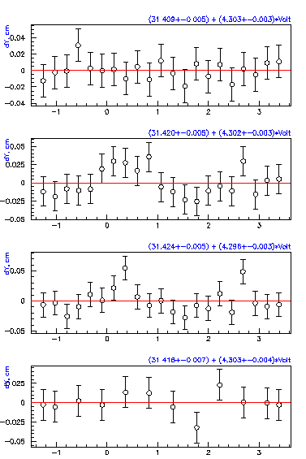

Figure 2. The residuals for the linear fit to the measurements of February, 2005. The height setting error: 0.2 mm.

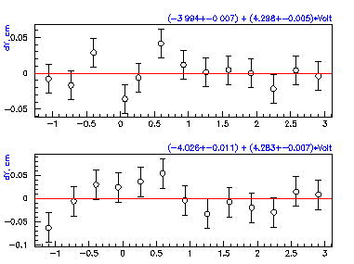

Figure 3. The residuals for the linear fit to Cassi’s calibration for runs 4254-4267 (upper plot, setting error: 0.2 mm) and 1388-1452 (lower plot, setting error: 0.32 mm)

Vishay-Sfernice 16 LH17F642H, 6.4 kΩ. Linearity: better than ±0.025%, see the product specs at http://www.vishay.com/docs/54016/16lh.pdf

