σ(E)/E, %
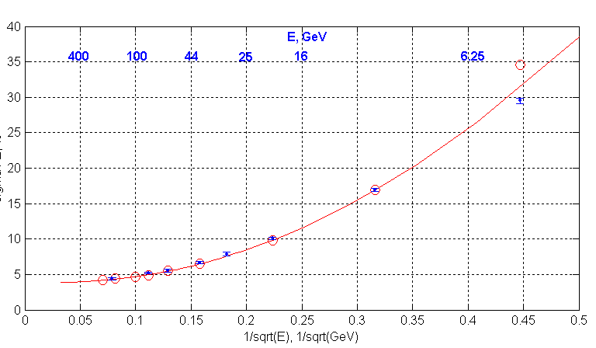
1/√E, GeV^{-1/2}
TB data

MC (G3)
electrons, 4L

